**Project 3- Sporty Shoes**

**Project and developer details**

The Project is developed by Aabitha Bathool

The all code of project is hosted on GitHub: -

<https://github.com/Aabidha/Phase3Project_Sporty-Shoes>

**Sprints planned and the tasks achieved in them**

Creating a document and file structure of the project.

Firstly, I create a Git repo and do Git Clone.

Then create a Maven Project which contains java files in src main and jsp files in views folder.

After completing all code, I have performed different test case on this project.

At last, I push all correct to GitHub.

**Algorithms and flowcharts of the application Core concepts used in the project**

Searching, Collections Frameworks, MySQL Connector, JSP, HTML, CSS, Hibernate, ORM, Controller, Autowired, RequestMapping.

**Project Details**

Create a Maven Project select archetype maven-archetype-webapp to created maven web project then fill groupID, ArtifactID.

**Creating packages like**

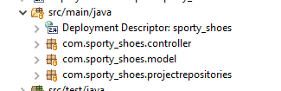

**Create a structure**

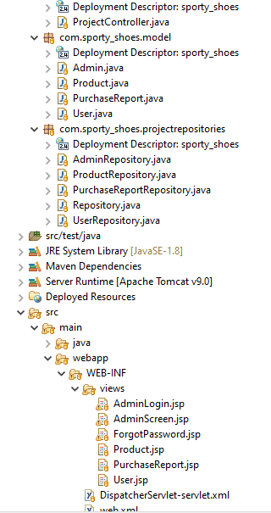

**Some Important Code Snippets –**

**Autowired and RequesMapping in ProjectController**

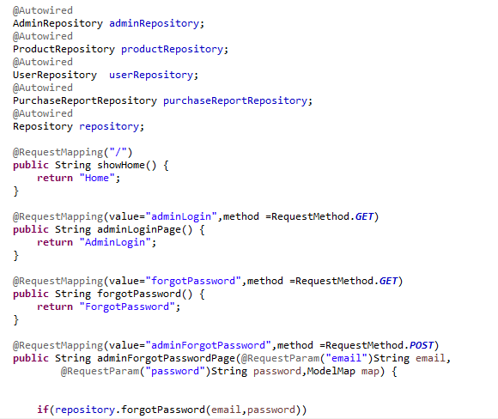

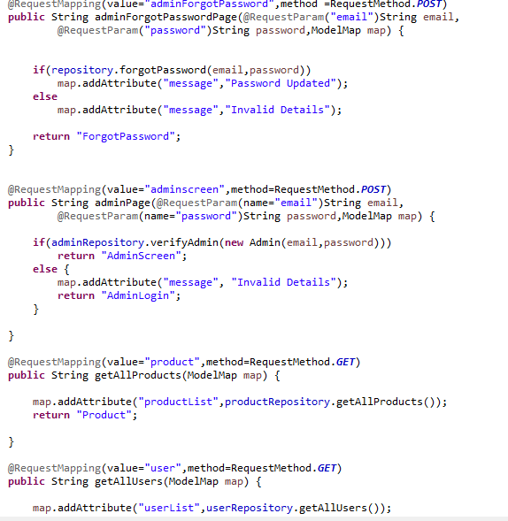

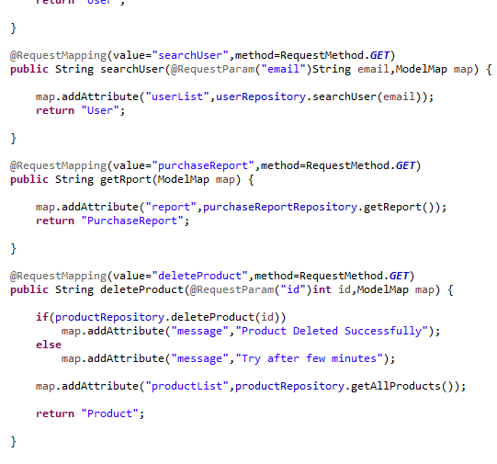

**Project Model**

**Admin model**

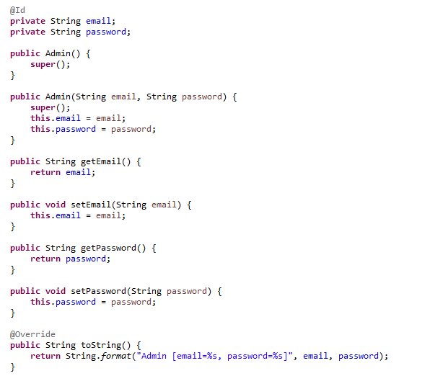

**Product Model**

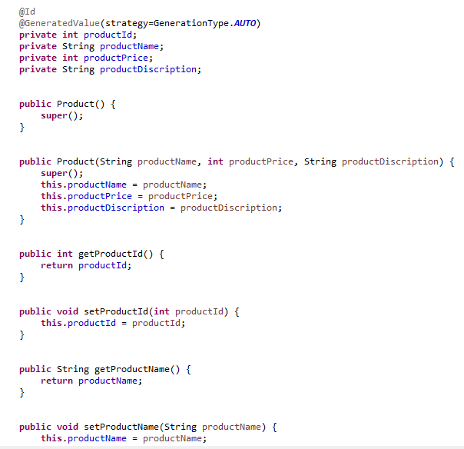

**PurchaseReport Model**

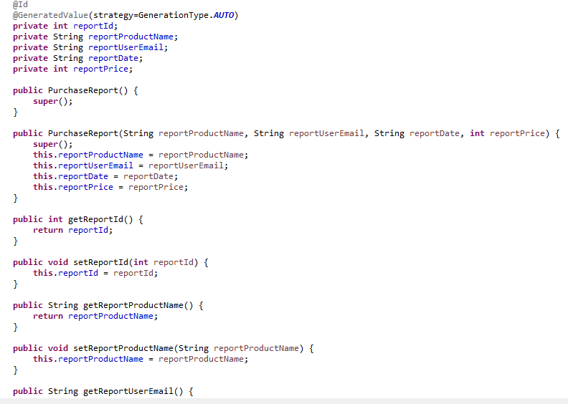

**User Model**

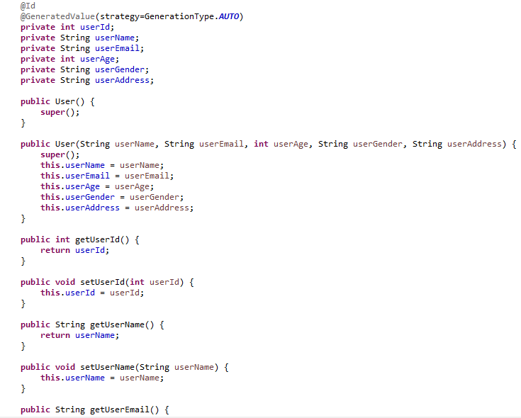

**Project Repositories**

**Admin Repository**

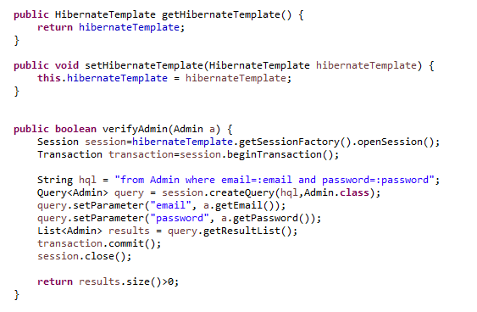

**Product Repository**

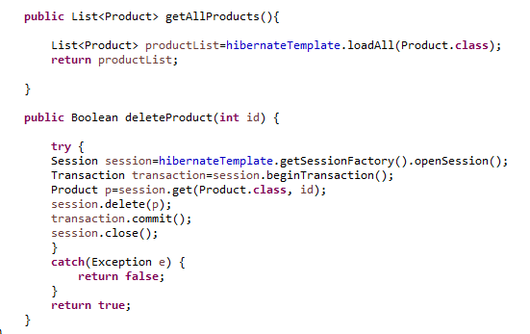

**Purchase Report Repository**

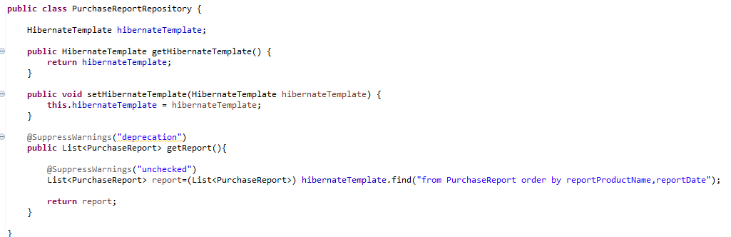

**User Repository**

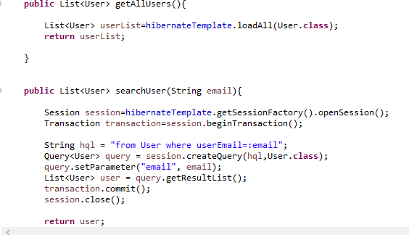

**Index jsp file main screen**

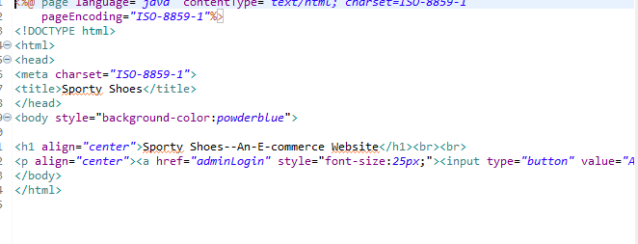

**Admin Table**

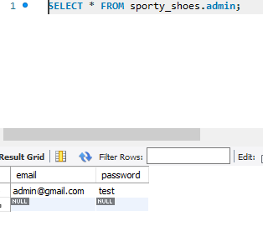

**Purchase Report Table**

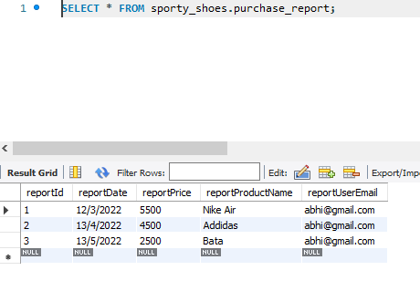

**User Table**

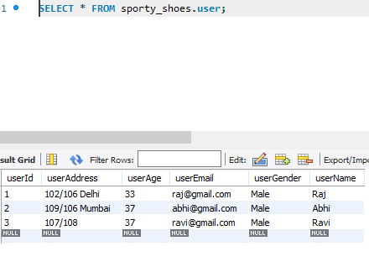

**Product Table**

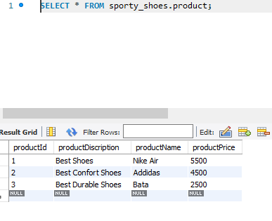

**Your conclusion on enhancing the application and defining the USPs (Unique Selling Points):**

A website with simple user interface and user experience.

A website which admin to maintain data of the website.

Admin can its password by clicking on forgot password.

Admin can see the product, purchase reports and users in website (track all data of the website).

Admin can delete the product also.

Admin can search the user by their email id.

**Some USPs –**

The application works very smoothly while taking inputs from the user.

The admin can easily.

The admin can change the password if he forgets

The admin can track all the data on the website such as see available products, users, Purchase reports.

The admin can search the users by their emails.

The admin can delete the products also.